**Police Prosecutor Update**

Issue No. 364  
October 2024

**Wilkins v. State of Indiana - Police Pat-Down Held to be Reasonable**

**2024 Ind. App. Unpub. LEXIS 1198 - Indiana Court of Appeals**

  Officers stopped a vehicle for making improper turns, emitting a loud exhaust leak, and failing to stop at a stop sign. When Officer Phelps approached the passenger side, he smelled the odor of burnt and raw marijuana and noticed Wilkins, the front-seat passenger, appearing nervous and avoiding eye contact. Phelps asked Wilkins to exit the car multiple times.  As Wilkins exited the vehicle, he reached for the gap between the front seat and the center console. Wilkins then had to be asked twice to put his hands on his head. Phelps testified that this caused him concern for his safety and the safety of other detectives on the scene.

After placing Wilkins in handcuffs, Phelps conducted a pat-down search of Wilkins’ waistband and front pockets. Phelps then moved Wilkins towards his police car to perform a further pat-down of Wilkins’ outer clothing. He felt a blunt object in Wilkins's chest area, which he believed to be a firearm. A Taurus 9-millimeter handgun was found in Wilkins's coat pocket. Wilkins was convicted of Unlawful Possession of a Firearm by a SVF.  He appealed, claiming the second pat-down was unconstitutional due to a lack of reasonable suspicion.

*Fourth Amendment Analysis*

“To conduct a pat-down during a *Terry* stop, an ‘officer need not be absolutely certain that the individual is armed; the issue is whether a reasonably prudent man in the circumstances would be warranted in the belief that his safety or that of others was in danger.’” Whether a pat-down was reasonable requires a totality of the circumstances analysis.  In this case, Phelps's observations of Wilkins’ behavior and movements, Wilkins’ delays in following instructions, and the smell of marijuana justified the pat-down, and police conduct was reasonable.

*Article 1, Section 11 Analysis*

The court also assessed the reasonableness of the pat-down under the Indiana Constitution using the *Litchfield* balancing test. This test considers “1) the degree of concern, suspicion, or knowledge that a violation has occurred; 2) the degree of intrusion the method of the search and seizure imposes on the citizen’s ordinary activities; and 3) the extent law enforcement's needs.” Wilkins did not contest the initial stop and conceded that the pat-down of his outer clothing was a mild intrusion. The court determined the degree of concern and police needs were high, based on the totality of the circumstances: Phelps observed the odor of burnt and raw marijuana; Wilkins appeared nervous and avoided eye contact; and Wilkins reached towards the center console area, leading Phelps to believe that Wilkins was armed or trying to conceal a firearm based on his training and experience.

*Conviction Affirmed*

---

**Laster v. State - Seizure of Cell Phone Pending Warrant to Search Upheld**

**2024 Ind. App. Unpub. LEXIS 1252 - Indiana Court of Appeals**

Alsham Laster was convicted of murdering his girlfriend, Latisha Burnett.

* July 11 - Laster's neighbor heard what she thought were gunshots coming from Laster's home. But the neighbor did not call the police because she "heard gunshots all the time in the neighborhood."
* July 12 - Laster called 9-1-1 using his cell phone. During the call, Laster identified himself and notified the police "there is a deceased person" in his home.
* July 13 - around 2:00 a.m., police stopped Laster while he was driving Burnett's Honda, took him to the police station for questioning, and seized Laster's cell phone.
* Police obtained a warrant to search the Honda. During their search, police found laundry detergent and a bag containing a pair of pants with several blood stains. DNA testing later confirmed most of the blood on the pants was Burnett's and a smaller portion was Laster's.
* July 14 - police applied for a warrant to search Laster's cell phone for potential evidence, like GPS and location data they expected to find on the cell phone. Approximately twenty-two hours elapsed between the warrantless seizure of Laster's cell phone and the trial court's grant of the warrant to search the phone.

Laster appealed his conviction, arguing the twenty-two-hour delay in obtaining a warrant to search his cell phone was unreasonable under the 4th Amendment and Article 1, Section 11 of the Indiana Constitution.

*Fourth Amendment Analysis*

“[A] law enforcement officer may temporarily seize property without a warrant if there’s ‘probable cause to believe [the property] holds contraband or evidence of a crime’ and ‘the exigencies of the circumstances demand it or some other recognized exception to the warrant requirement is present.’”

Whether exigent circumstances exist depends on: (1) whether there was probable cause to believe the item contained contraband or evidence; (2) whether the police had reason to fear evidence would be destroyed; and (3) whether they balanced law enforcement needs against personal privacy.

Given that Laster called police to report Burnett’s body and other evidence indicated Laster may have committed the murder, police had probable cause to believe the call logs, location information, etc., held in Laster’s phone may be relevant evidence.

If the police had returned Laster's phone after his interview, he might have destroyed incriminating evidence. To avoid this, they secured his phone while applying for a warrant.

Laster had a strong privacy interest in his phone, but the police didn’t search it until after obtaining a warrant, so his privacy was not adversely affected.

The Court then considered the brevity of the seizure, and whether police diligently pursued their investigation. During the twenty-two hours between seizing the phone and obtaining a warrant, police were investigating the murder, demonstrating diligence.

*Article 1, Section 11 Analysis*

The reasonableness of a search or seizure is determined by balancing: (1) the suspicion of a violation, (2) the degree of intrusion, and (3) law enforcement needs. When police seized Laster's phone, they had moderate suspicion based on evidence found at the scene, including Burnett's body and signs of a homicide. The intrusion was minimal since police did not search the phone until obtaining a warrant, meaning Laster’s privacy remained intact. Though a twenty-two-hour deprivation of possession is notable, it was reasonable in the context of a homicide investigation. Seizing Laster's phone in anticipation of a warrant to search it was justified to prevent him from deleting incriminating evidence in the interim.

*Conviction Affirmed*.

Drug School

Methamphetamine

Methamphetamine is a Schedule II stimulant under the Controlled Substances Act, which means that it has a high potential for abuse and a currently acceptable medical use (in FDA-approved products).

Common street names include: Batu, Bikers Coffee, Black Beauties, Chalk, Chicken Feed, Crank, Crystal, Glass, Go-Fast, Hiropon, Ice, Meth, Methlies Quick, Poor Man’s Cocaine, Shabu, Shards, Speed, Stove Top, Tina, Trash, Tweak, Uppers, Ventana, Vidrio, Yaba, and Yellow Bam.

Regular meth is a pill or powder. Crystal meth resembles glass fragments or shiny blue-white “rocks” of various sizes. Meth is swallowed, snorted, injected, or smoked. To intensify the effects, users may take higher doses of the drug, take it more frequently, or change their method of intake.

DIFFERENT FORMS OF METHAMPHETAMINE

Below are the various forms that methamphetamine can be seen on the street.

Clear “glass” fragment

Powder form

White fragment “shards”

Brown Powder form

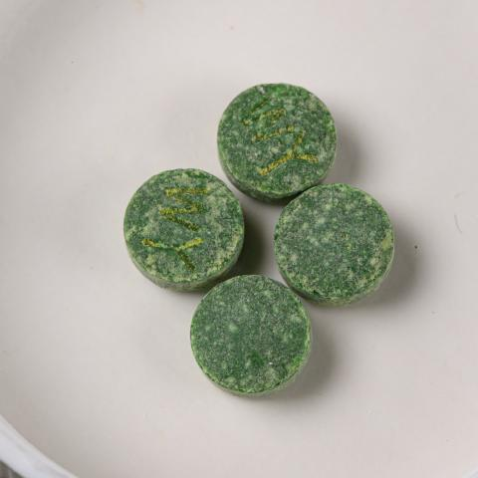

Pressed into pills

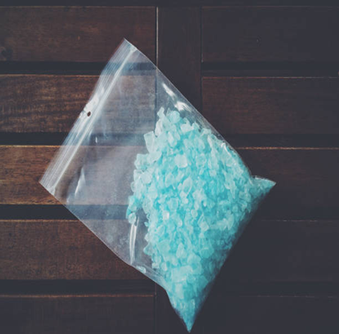  
Upcoming Training

Blue crystal shards

IPAC Winter Conference- December 9-11, 2024, at the Westin Hotel, Downtown Indianapolis

More Infor and register on our website!

This is a publication of Indiana Prosecuting Attorneys Council which will cover caselaw and various topics of interest to law enforcement officers. Please direct any questions or suggestions you may have for future issues to Dave Thornburg, Drug Resource Prosecutor at IPAC – DaThornburg@ipac.in.gov